Purpose of the work: to consolidate the color theory by creating a planar (half-volume) composition for interior decoration.
Objective: to work out the color theory on the basis of creating a planar or semi-volume composition of natural materials that is harmonious in form and color solution. Materials and tools: a sheet of hard cardboard or thick colored (white) paper of any size, paints of any type, floristic planar and semi-volumetric material (dried leaves, flowers, inflorescences, petals, fluff, twigs, straw, bark, etc.), non-floral material (threads, sisal, etc.), PVA glue, thermal glue.
Basic information
Types of plane compositions depending on the plot: - thematic; - storyline; - animalistic (image of people, animals, birds); - landscape; - still life; - abstraction; - ornamental.
Types of planar compositions depending on volume: planar, tonal (volumetric) and volumetric convex. Plane applique is the easiest to perform. It repeats the silhouette of the depicted object or animal - a leaf, flower, tree, bird. Of the material in planar applique, they give preference to leaves and petals.
In floristry, all the details of the pattern are made of solid or cut natural material, which has an almost uniform color and, therefore, the image is flat.
A more complex method is a planar tonal application. As in painting, the effect of the volumetric, convexity of the depicted object is achieved by the selection of shades: light details seem to approach the viewer, while dark ones move away from him. In this case, not only artistic flair, but also a set of natural material rich in shades will help to achieve good results.
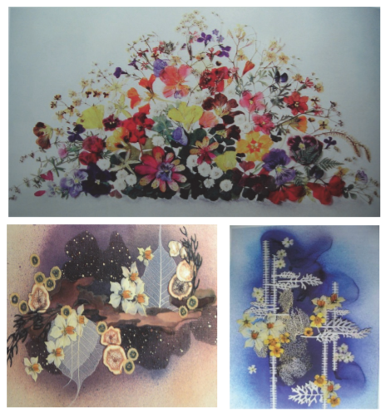
Examples of planar compositions

To create a volumetric-convex applique, individual details of the composition (for example, petals of large flowers - blown by the wind sails, domes of ancient cathedrals) are pre-bent, make them convex using a heated metal spoon or the spout of a warm iron.
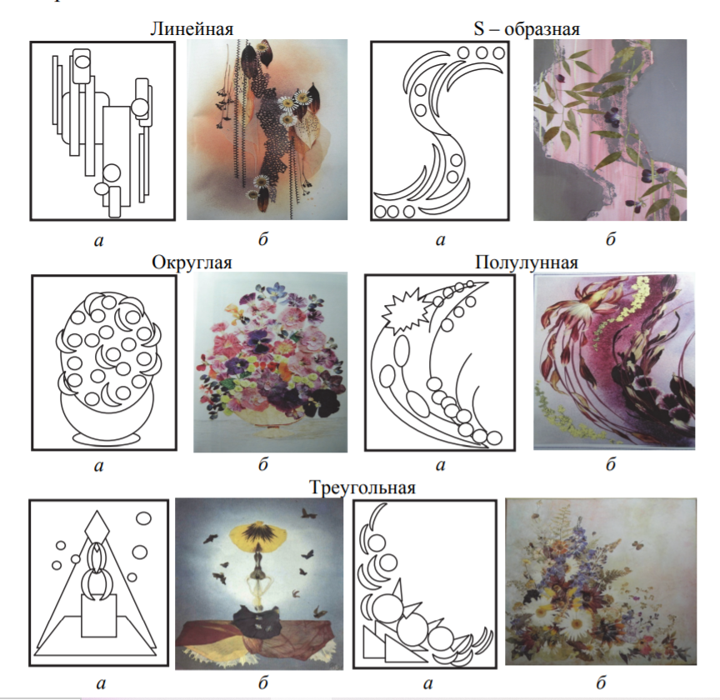

Examples of planar compositions
a - diagrams of planar compositions; б - options for ready-made planar floristic compositions

When working with the applique technique, it is important to remember:
- items are presented in a conditionally simplified form,
that is, they are stylized and located not in the environment, but outside it;
- the absence of transmission of the light-air medium is possible and
perspective, therefore it is necessary to find special spatial relationships between objects and the plane of the sheet;
- the emotional-associative perception of the objective world plays an important role in solving the composition;
- in objects it is necessary to see the general, most characteristic features that distinguish it from others;
- when working with plant material, we have forms already created by nature, in which we need to consider the features of themselves
items.

Work order
Manufacturing technology of compositions from plant material (collage)
1. Think over the plot of the future picture.
2. Think over the color scheme of the picture (warm, cold,
contrasting, nuanced).
3. Make a color sketch on paper. It is desirable to develop
several options, then you can choose the best one.
4. After selecting a sketch, plant material is selected
so that it emphasizes the main idea of the work.
5. Using scissors, slightly give the details a more similar shape, create more expressive images and objects.
6. Pick up the background.
For the background, you can use the following materials: black wrapping paper (from photographic paper or X-ray films); velvet paper of dark colors; plain fabric - silk, velvet, broadcloth, flannel, satin, canvas, burlap, thick cotton fabric, synthetic fabrics; leather, dark leatherette with a smooth surface without a pattern; polished boards in black or dark brown; thin boards from trees of different species; thin sheets of plywood, veneer, usually used for finishing furniture; bark of pine, birch and other trees; decorative cardboard; thick paper - white or pastel colors; embossed wallpaper, turned seamy side; panels and napkins made of straw, without drawings and decorations; leaves of silver poplar, elecampane, chernobylnik, raspberry, cinquefoil, sucker, bear's ear, forest geranium, coltsfoot, holly, pinkish-purple sycamore, laid on the velvet side, corn leaves, dried moss glued to cardboard. The color and structure of the background must match the color and structure of the plant material from which the work is made, and correspond to the technique of execution.
7. The selected natural material is laid out on the prepared background in accordance with the sketch and the work is carefully examined. If the desired result is achieved, you can proceed to the next stage of work.
8. Gluing plant material on the background along the outlined contours.
9. Registration of work with a frame or mat. For such "plant" paintings, special frames with glass are required, but standard frames can be used.

Pictures look more interesting in deep frames. The color of the frame should match the color of the work. Some plant compositions can be decorated using a cord woven using the macrame technique. This design option is suitable for oval or round work.
Design of finished works.
The correct design will help the work to live a longer life, emphasize its dignity.
To protect work made of a fragile natural material from dampness, drying out, dust, it must be edged, protected with glass or film.

- Prepare the material for the base of the painting, make hanging loops on the base. The size of the base should correspond to the size of the background or mat. In order for the work to be hung on the wall, hinges are needed. They are fixed at an equal distance from the lateral sides with an indent of 4–6 cm from the upper edge. To do this, in the right place on the base, two cuts are made (the width of the cut is equal to the width of the loop) and loops are threaded through them. The ends of the hinges are fixed on the back side; they can be glued to the base with glue.
- Attach the background to the base of the picture. 1-3 sheets of newsprint are glued onto the surface of the base, greased with glue at several points. Then the background is pasted onto the newspaper sheets. Glue is applied to the background along the perimeter, and in the middle it is enough to lubricate several points - in this case, if necessary, the background will be easily removed from the base. The glued background is covered with a clean sheet of paper and left under the load until the glue is completely dry.
- Creation of passepartout. Passepartout is made of the following materials: thick smooth or tinted paper; velvet paper in black, dark blue, green, cherry, brown; decorative paper imitating wood, leather, fabric; decorative cardboard; veneer of various tree species with a beautiful pattern; plant material. The size of the mat is proportional to the size of the composition. The top and side margins should be equal in width, the bottom margin may exceed the top one by 1.5–2 times in width, that is, the “window” on the plane of the picture is as if slightly shifted upward. Passepartout is made according to the size of the base of the picture. Narrow fields visually reduce the composition, especially landscape. Too wide margins can "crush" a picture if it is not large in size. The "window" in the mat should be 0.3–0.5 cm less than the size of the picture; it is carefully cut out with a knife along a ruler. Most often it is rectangular or square, but you can make a mat with a round or oval "window". Passepartout with a round "window" is made on the basis of a square, glass for the decoration of the picture is also used square. Passepartout with an oval "window" requires a rectangular shape.
- Strengthening the composition on the background. When strengthening the composition on the background, you should not apply glue to the entire surface of the part - just a few small dots in different places. In this case, if any malfunctions or errors are found, you can gently bring a thin knife blade under the fixed part and, by slightly pressing, separate the part or part of it from the background, correct and reattach it to the background, trying to hide the remaining glue spots.
- Glazing the finished work. Deficiencies in the composition will be more noticeable if the work is closed with glass and examined from a distance (preferably after a while). Glass should be chosen durable, without glare on the surface, without irregularities, bubbles, scratches, cracks. Its thickness should not exceed 0.3 cm, since thick glass distorts the color of the plant material and makes the weight of the finished work heavier.

